**Spoken Tutorials - Linux Assignment**

**Indian Institute of Technology Bombay,**

**http://spoken-tutorial.org**

**File Attributes**

1. Create a file abc.txt and change the ownership of this file to some other user on your machine,

and also change the group to family.

2. Create a file exercise.txt and make it executable.

3. Create a file test.txt on your desktop and identify its inode number, also create a softlink for test.txt in your home.

**Answers:**

**1)**

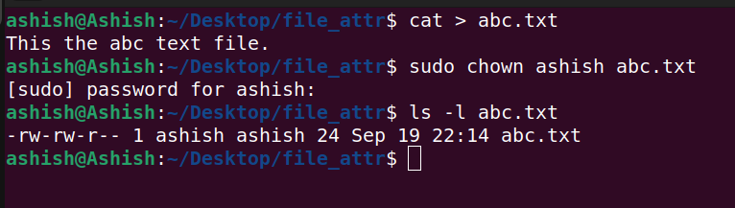

There is only 1 user in my ubuntu. Hence, I’ve entered the command-

**sudo chown ashish abc.txt**

However replacing “ashish” with a uder’s name will change the ownership.

**2)**

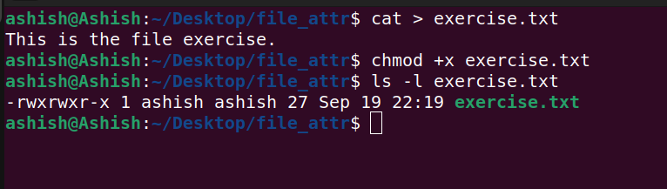

Steps:

1) Created a text file using **cat > exercise.txt** command.

2) Made it executible using **chmod +x exercise.txt** command.

3) To check, We enter the command: **ls -l exercise.txt.**

**3)**

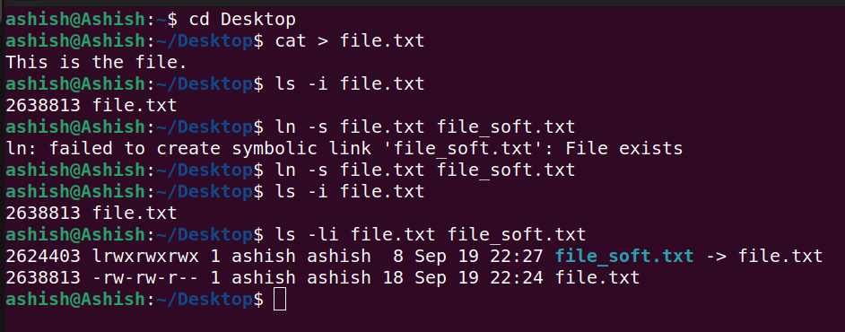

Steps:

1) Created a text file – file.txt.

2) It’s inode no is seen by: **ls -i file.txt.**

3) A softlink is created using **ln -s file.txt file_soft.txt.**

4) **ls -li file.txt file_soft.txt** is used to see both inode numbers